**Book Store API Backend**

**1.GET REQUEST : Retrieving a list of all books**

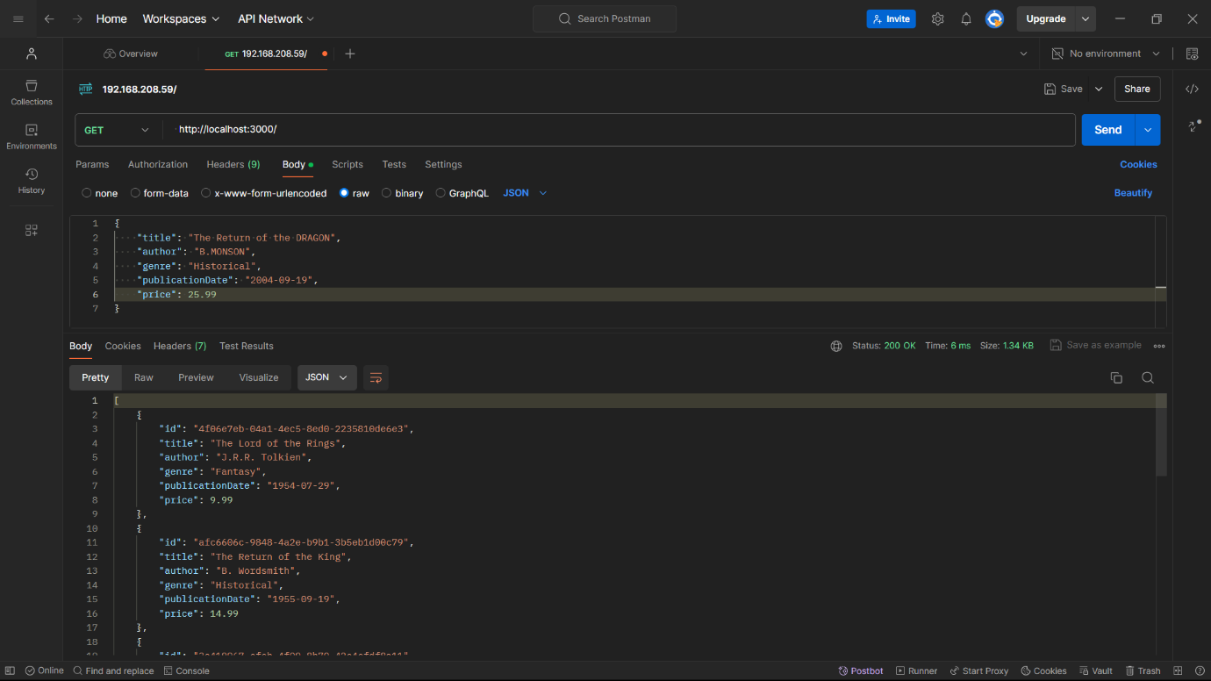

**2.GET REQUEST BY ID : Retrieving details of a specific book by its ID.**

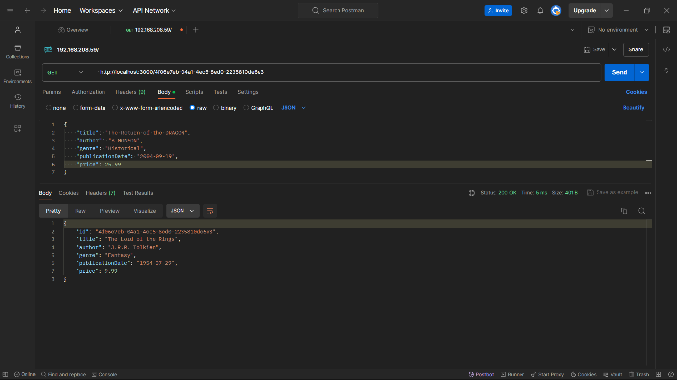

**3. POST REQUEST : Adding a new book to the inventory  
  
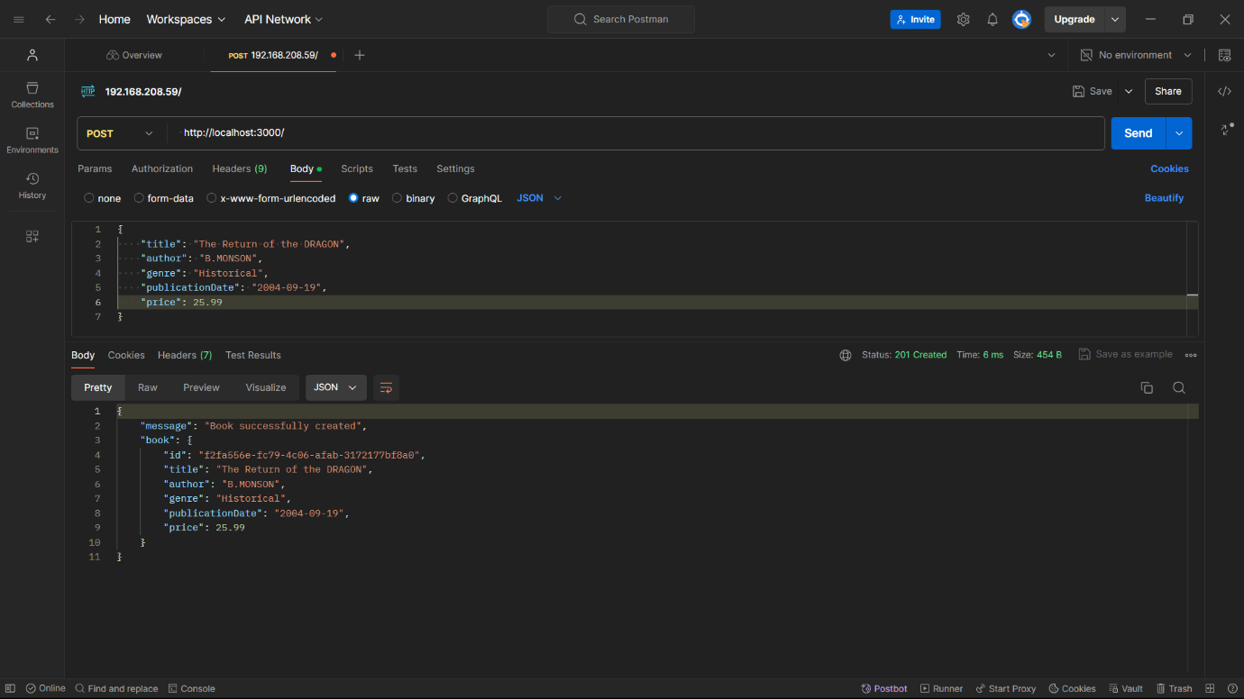**

**4. DELETE REQUEST : Deleting a book by its ID from the inventory**

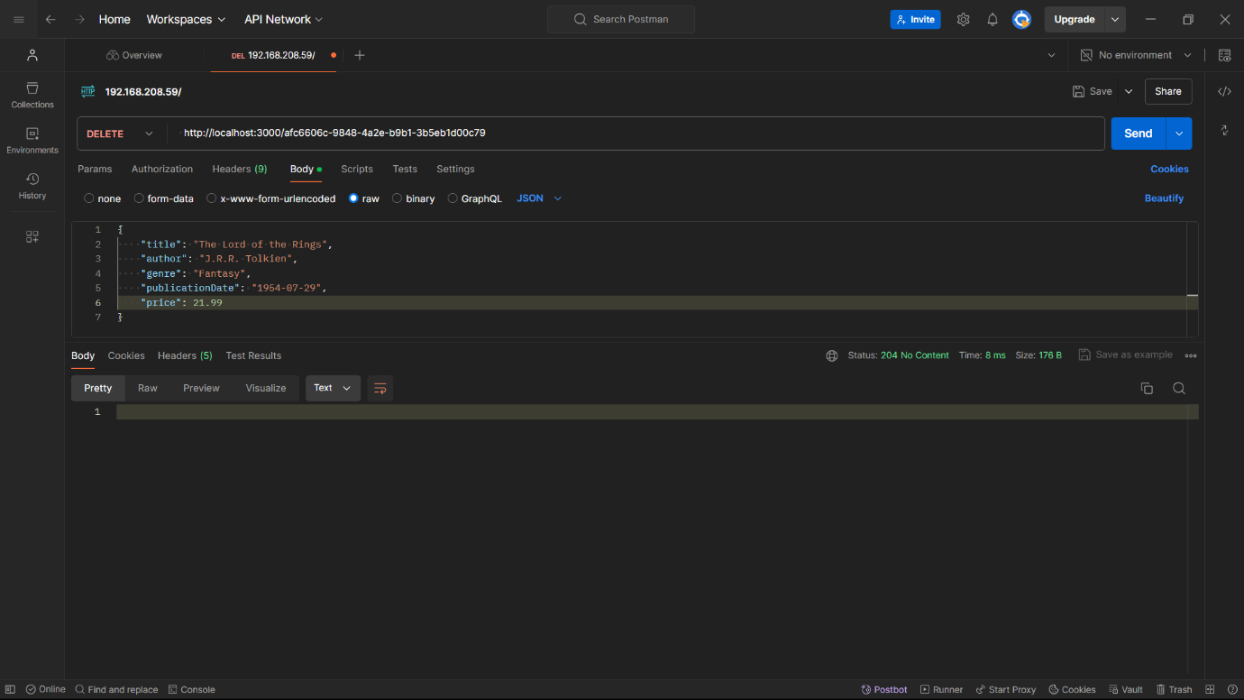

**After Deleting :**

